Unit 2 What time is it?单元检测
一、选出与所给单词画线部分发音相同的一项（5分）
( )1. nurse A. number B. bird C. water
( )2. breakfast A. teacher B. real C. bread
( )3. thirty A. today B. forty C. way
( )4. class A. art B. apple C. library
( )5. hurry A. music B. run C. computer
二、选出与所给的词属于同一类的一项（5分）
( )1. lunch A. dinner B. class C. floor
( )2. go home A. home B. school C. go to bed
( )3. thirty A. first B. forty C. second
( )4. English class A. PE class B. music C. art
( )5. run A. this B. go C. now
三、将合适的词或句子的序号填到图片下面的括号里（5分）
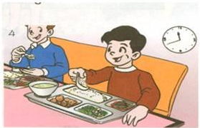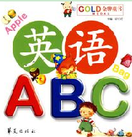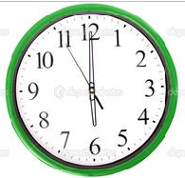
（ ） （ ） （ ） （ ） （ ）
A. It’s 6 o’clock. B. get up C. lunch D. It’s time to go home. E. English class
四、单项选择（10分）
( )1. Class is __________.
A. go B. run C. over
( )2. —_________
——It’s 5 o’clock.
A. What time it is? [来源:Zxxk.Com]
B. What colour is it?
C. What time is it?
( )3. It’s time ________ breakfast.
A. for B. in C. on
( )4. It’s time for English class. _________
A. Let’s eat some rice. B. Let’s read and write.
C. Let’s jump and run.
( )5. Dinner is ________.
A. ready B. run C. vegetable
( )6. ________ It’s time to get up.
A. I’m full. B. It’s 9 p.m. C. Hurry up!
( )7. It’s time ________ go to bed.
A. to B. for C. and
( )8. ——It’s time for bed.
——________
A. Come on. B. Just a minute. C. It doesn’t matter.
( )9. ——Where is Amy?
——_________
A. He’s in the library.
B. He in the computer room.
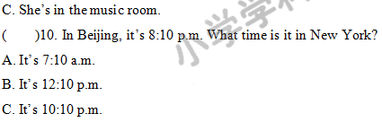
五、圈出正确的单词（5分）
1. Time ________(for, to) go home.
2. ________ (Come, Home) on, Amy!
3. Let’s ________(to, run)!
4. It’s time ________(to, for) music class.
5. —________(Where, What) is Mike? —He’s in the classroom.
六、选出合适的答语（10分）
( )1. What time is it now? A. Let’s have some chicken.
( )2. It’s 6 o’clock. B. I am in the music room.
( )3. It’s time for lunch. C. It’s 8 o’clock.
( )4. Where are you? D. It’s time to get up.
( )5. It’s time to get up. E. Just a minute.
七、连词成句（10分）
1. ten, is, o’clock, it(.)
_______________________________________________________
2. sing, let’s, dance, and(.)
_______________________________________________________
3. for, class, time, English, it’s (.)
_______________________________________________________
4. is, time, it, what (?)
_______________________________________________________
5. to, time, school, to, it’s, go (.)
_______________________________________________________
八、选择合适的句子填入横线，只填序号（10分）
Mum: 1. ________ It’s time for breakfast.
Mike: 2. ________
Mum: It’s 7:00 now.
Mike: 3. ________[来源:Zxxk.Com]
Mum: Breakfast is ready. 4. ________
Mike: Milk and bread? 5. ________
A. Just a minute.
B. What time is it now?
C. OK.
D. Hurry up!
E. Let’s drink some milk and have some bread.

九、阅读理解，根据短文内容填写表格（10分）
I’m John. I’m in Class 3. I get up at 6:50 a.m. It’s 7:10 a.m. It’s time for breakfast. I go to school at 7:30 a.m. I have English class at 8:00 a.m. What time is it now? It’s 8:50 a. m. It’s time for Chinese class. I have music class at 10:40 a.m. It’s 11:30 a.m. It’s time for lunch. I like chicken. Let’s have some chicken. I have PE class at 2:30 p.m. It’s 4:30 p.m. It’s time to go home. I have dinner at 6:30 p.m. Come on! It’s 9:00 p.m. It’s time to go to bed.
6:50 a.m. | get up
 | breakfast
7:30 a.m.
8:00 a.m.
 | Chinese class
10:40 a.m. | [来源:学_科_网Z_X_X_K]
11:30 a.m.
 | PE class
 | go home
6:30 p.m.
9:00 p.m.

十、写写吧
根据右边的课程表，完成短文，描述一下你这一天的学校生活。
I go to school at 7:30. I have _______ class at 7:50. It’s 8:30. It’s time for Chinese class. I go to the _______ room at 10:40. I have lunch in the canteen at 11:30. I have _______ class at 2:30. I go to the art room at 3:50. It’s _______. It’s time to go home.
7:30 | 去上学
7:50 | 英语课
8:30 | 语文课
10:40 | 计算机课[来源:Zxxk.Com]
11:30 | 吃午饭
2:30 | 音乐课
3:50 | 美术课
4:30 | 回家

参考答案：
一、
1. B 2. C 3. B 4. A 5. B
二、[来源:Z&xx&k.Com]
1. A 2. C 3. B 4. A 5. B
三、
1. B 2. C 3. E 4. A 5. D
四、
1. C 2. C 3. A 4. B 5. A
6. C 7. A 8. B 9. C 10.A
五、
1. to 2. Come 3. run 4. for 5. Where
六、
1. C 2. D 3. A 4. B 5. E
七、
1. It’s ten o’clock.
2. Let’s sing and dance.
3. It’s time for English class.
4. What time is it?
5. It’s time to go to school.
八、
1. D 点拨：既然后面说“到了吃早饭的时间了。”那么前面最合适的就是“快点！”。
2. B 点拨：既然回答“现在七点了。”那么就问“现在几点了？”。
3. A
4. E
5. C
九、略
十、English；computer; music; 4:30

